 Big Idea John the Baptist testified that Jesus is the Messiah, not the Messiah.

John 1:14-18 ¹⁴ And the Word became flesh and dwelt among us, and we have seen his glory, glory as of the only Son from the Father, full of grace and truth. ¹⁵ ( John bore witness about him, and cried out, "This was he of whom I said, 'He who comes after me ranks before me, because he was before me.'") ¹⁶ And from his fullness we have all received, grace upon grace. ¹⁷ For the law was given through Moses; grace and truth came through Jesus Christ. ¹⁸ No one has ever seen God; the only God, who is at the Father's side, he has made him known. |  Three Key Questions  - What is a key word in this passage?  - What is a key verse in this passage?  - What is a key tone of voice of this passage?   Text-based Questions  - What does it mean that the Word became flesh? (v. 14a)  - What is the result of incarnation? (v. 14b-18)  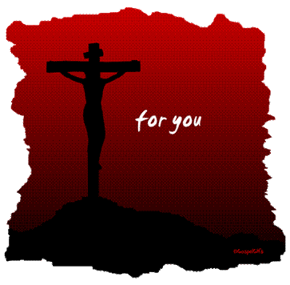 Three Christ-centered Questions  - Who is Christ in this passage? (John 1:14)  - Who is Christ to you?  - Who are we in Christ?
Spirit-led Application
John the Baptist’s witness
John 1:19-34

